**PROBLEM STATEMENT**

**Caeser Encryption**

Encrypt and Decrypt the content of a whole file by using the Caeser encryption and shifting the letters by a certain number and save the output to another file – and the reverse process.

Requirements:

1. Discuss between the pair and document the final requirements and scope that you plan to implement.

*Scope and final requirements decision will be DIY.*

1. Start on the implementation of the decided scope and requirements.
2. Try to involve Kafka in some way if possible (Hint: as a way to input data) – Not Compulsory

**SETUP**

**Python Installation**

For this project, we were asked to install the latest stable version of the Python 3.9 series. You can download the setup using the following link:

<https://www.python.org/downloads/>

After installation, you can check the installed version of python and if it has been installed correctly.

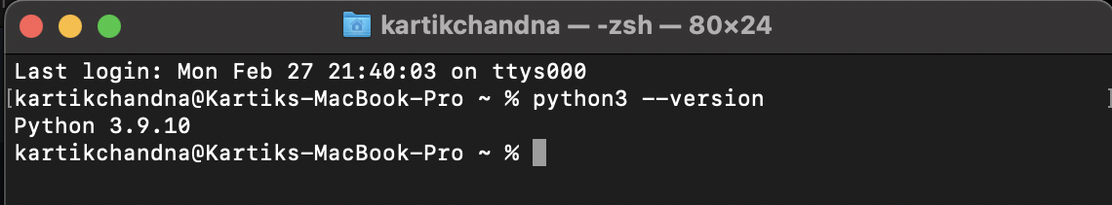

**Java Installation**

Before installing Kafka, we need to install Java (Version 8 or above). You can download and setup using the following link:

<https://www.oracle.com/java/technologies/downloads/>

After installation, you can check the installed version.

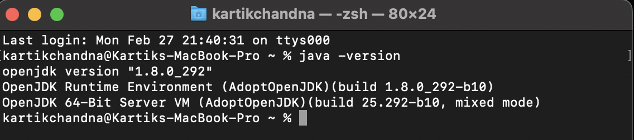

**Kafka Installation:**

For this project we were asked to use Kafka. So, we downloaded the latest version of Kafka using the following link:

<https://kafka.apache.org/downloads>

**Additionally, install an IDE of choice and push the code on Git as you go.**

**Flow of the project:**

* + Initiate the terminal for consumer and producer in 2 different terminal windows.
  + Run the producer.py and then the consumer.py file
  + The data from the 1st file will get pushed to the pipeline by the producer and pulled by the consumer to encrypt or decrypt in a different file.

For the code, visit the github repo:

https://github.com/AsthaPatwa/kafka-python